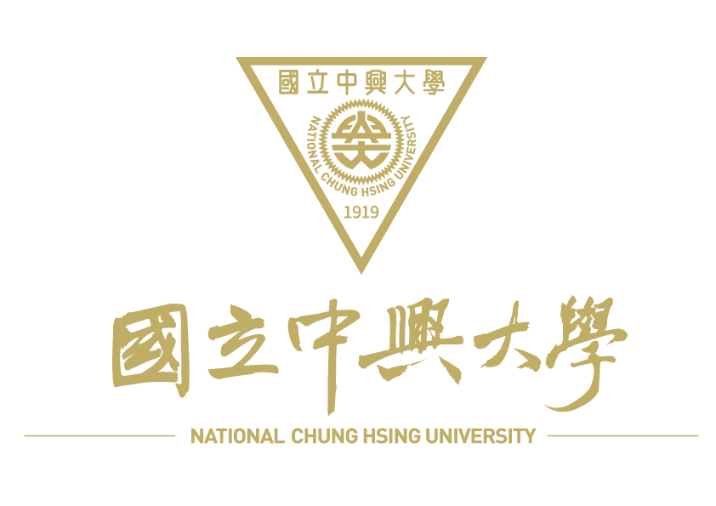

質譜分析服務申請表MS Service Request Form
蛋白質體暨代謝體質譜核心實驗室Proteomics & Metabolomics Mass Spectrometry Core Facility
2026.01 ver. 核定文號1152300010

編號 |  | 收件者
收件日期 |  | 收件者

申請者資料Client Information
實驗室主持人PI name |  | 實驗室主持人簽章PI signature
單位名稱Dept. |  | 申請日期Date
聯絡人Contact Name |  | 聯絡電話 Tel | ( )
E-mail |  | 校內/計畫編號(收據/發票)/  校外/統一編號(發票)
發票郵寄地址Address：
本表單蒐集之個人資料僅限於本項服務業務所需之聯繫使用，非經當事人同意絶不轉做其他用途，亦不會公布任何資訊，並遵循本校資料保存與安全控管辦理。當事人同意後簽名。 當事人簽名： (請親簽) 年 月 日
樣品特性敘述Sample information
樣品名稱或代碼Sample name |  | 樣品數量 | 所屬物種Taxonomy (genus/species)
樣品來源sample source： □ 動物Animal (□Tissue □Culture cell □Serum) □ 植物Plant □ 微生物Microorganism
樣品狀態sample status： □ 固態粉末 Powder □ 水溶液 Solution □ 膠體 Gel (Gel photograph □ Y □ N)
是否含鹽類salt containing? □ No □ Yes:
是否含有清潔劑Detergent containing? □ No □ Yes: □SDS □Triton-100X □Others:
蛋白質/胜肽類樣品Protein / Peptide sample
1. 種類sample type --- □ protein □ peptide
2. 染色方式stain method --- □ Coomassie blue stain □ Silver stain □Others:
3. 估計分子量approximate mass kDa
4. 蛋白質含量protein content □ µg □ mM
5. 可能修飾基variable modification:
6. 水溶液樣品之溶劑種類main solvent of liquid sample:
小分子化合物定量Small molecule quantification  1. 目標物分子量Target monoisotopic mass  2. 請提供目標物分子式、結構式、標準品Stock 1mg / 原液20 µl以上，及相關參考文獻。Please provide the target compound's molecular formula, chemical structure, a minimum of 1 mg (powder) or 20 µL (stock solution) of the standard, and relevant references. |  |  |  | 小分子化合物定性Small molecule identification  1. 檢測目標/數量Detection Target / Amount：  □ 正離子Positive Ion /  □ Top 10 □Top:  □ 負離子Negative Ion /  □ Top 10 □Top:
請說明樣品處理方式Please describe the sample preparation method：

揮發性化合物鑑定Volatile Compound analysis
1. 樣品狀態sample status： □ 液態 Liquid □ 氣態 Gas
2. 是否需要SPME濃縮/萃取SPME Concentration/Extraction： □ Y □ N
樣品儲存Sample Storage | □-20℃(defult) □4℃ □室溫RT □其他other:
申請者備註 User’s message about the sample (請詳述任何有助於分析的資料)

- 本實驗室不接受放射性樣品及毒性樣品。 We do not accept radioactive samples and toxic samples.
- 請盡量降低鹽類含量，尤其不可含有磷酸鹽和清潔劑。樣品請保存於水或0.1％ formic acid內。Please try to reduce the salt content, especially the phosphate and detergent. Please store the sample in water or 0.1％ formic acid.
- 校外單位首次送測，須先完成繳費後，方進行樣品分析。For first-time external clients, sample analysis will commence only after the payment has been completed.
- 本實驗室非國家認證檢驗機構，檢測報告僅供學術研究參考，嚴禁用於法律訴訟、廣告宣傳或商業證明。受限於資源與設備排程，本服務不提供任何形式之複測。申請人提交樣本即表示同意上述條款，並自行負擔樣本代表性之責任。This lab is a non-certified facility. Our results are for academic research use only and are strictly prohibited from being used for legal, promotional, or commercial purposes. Please note that no re-testing services are provided. By submitting this application, you agree to these terms and accept responsibility for the quality and representativeness of your samples.

# | 服務項目(使用儀器) Service Item (Instrument) | 校內單價(元)  (NTD; on-campus) | 校外單價(元/未稅)  (NTD before tax; off-campus) | 數量  Amount | 備註Notes
1-1 | 胜肽或蛋白質分子量測定Peptide/ Protein Mass Analysis (MALDI–TOF) | 800 /sample | 1,500 /sample |  | 提供質譜圖。Mass Spectra & Mass List Provided.
2-1 | 蛋白質身分鑑定Protein Identification I (MALDI – TOF) | 1,000 /sample | 2,000 /sample |  | 提供Mascot軟體比對結果。Mascot PMF search results provided.
2-2 | 蛋白質身分鑑定Protein Identification II (LC/MS/MS) | 2,000 /sample | 3,000 /sample |  | 層析梯度70分鐘、提供Mascot軟體(MS/MS Ion search)結果。70-minute LC gradient / Mascot (MS/MS Ion search) results provided
2-3 | 蛋白質身分鑑定Protein Identification III (LC/MS/MS) | 3,000 /sample | 4,000 /sample |  | 層析梯度150分鐘、提供Mascot軟體(MS/MS Ion search)結果。150-minute LC gradient / Mascot (MS/MS Ion search) results provided
3-1 | 正電小分子化合物鑑定Positive Small Molecule Identification (LC/MS/MS) | 2,000 /sample | 3,000 /sample |  | 提供正電訊號前10強預測化合物、質譜圖。Positive Ion Mode: Top 10 predicted compound identifications and mass spectra provided.
3-2 | 負電小分子化合物鑑定Negative Small Molecule Identification (LC/MS/MS) | 2,000 /sample | 3,000 /sample |  | 提供負電訊號前10強預測化合物、質譜圖。Negative Ion Mode: Top 10 predicted compound identifications and mass spectra provided.
3-3 | 小分子化合物鑑定-增加比對Small Molecule Identification - Additional Library Matching | 500 /10 candidates | 500 /10 candidates |  | 前11強起每10個為單位收費。Charging in units of 10 for every additional 10 items beyond Top 10.
3-4 | 小分子化合物定量Small Molecule Quantification (LC/MS/MS) | 2,000 /sample | 3,000 /sample |  | 提供絕對定量數據。Absolute quantification results provided.
3-5 | 小分子化合物定量-標準品檢量線 Calibration Curve (LC/MS/MS) | 10,000 /std. | 15,000 /std. |  | 由使用者提供純度99%以上標準品，拉5個濃度檢量線。User to provide standard with >99% purity for generating a 5-point calibration curve.
3-6 | 目標物標準品測試 MS Optimization (LC/MS/MS) | 1,000 /std. | 2,000 /std. |  | 由使用者提供純度99%以上標準品及相關參考文獻。User to provide standard with >99% purity & relevant references.
4-1 | 揮發性化合物鑑定Volatile Compound Analysis (GC-MS) | 2,000 /sample | 3,000 /sample |  | 提供層析圖及定性化合物清單。Total ion chromatograms and a list of identified compounds will be provided.
5-1 | 前處理Pretreatment I | 500 /sample | 500 /sample |  | ZipTip或SPE去鹽及濃縮。ZipTip or SPE Desalting & Concentration.
5-2 | 前處理Pretreatment II | 1,000 /sample | 1,000 /sample |  | Trypsin酵素水解及去鹽。Trypsin Digestion, ZipTip Desalting, & Concentration.
5-3 | 前處理Pretreatment IV | 1,000 /sample | 1,000 /sample |  | SPME萃取。SPME Extraction.
6-1 | 實驗技術諮詢Consultation | 250 / 30 min | 500 / 30 min |  | 如數據解釋、軟體使用等，可實體或線上進行。Consultation services (including data interpretation and software training) can be conducted on-site or virtually.
6-2 | 正式報告Official Data Report | 500 / case | 500 / case |  | 提供電子檔。Digital copy only.
6-3 | 客製化服務Customized Services |  |  |  | 視情況報價收費。Quotation upon request.
大量送件優惠：一次送件量>10個95折優惠; >20個9折優惠; >30個85折優惠; >50個8折優惠。  Bulk Submission Discounts: > 10 samples: 5% off; > 20 samples: 10% off; > 30 samples: 15% off; > 50 samples: 20% off. |  |  |  |  |  | 自備column 9折優惠。10% off if providing your own column.  前處理無優惠。No discounts available for pretreatment services.
蛋白質體暨代謝體質譜核心實驗室Proteomics & Metabolomics Mass Spectrometry Core Facility 2026.01 ver. 核定文號1152300010

